Initial Evaluation Procedures

- Send home Permission to screen letter.

- After screening, if a child has significant developmental errors and you determine that he needs further testing, have the classroom teacher complete a referral packet for Special Education Services. The packet must be completely filled out. Vision and hearing must be completed before accepting the packet. The SBLC members and principal must sign the referral packet. It is a good practice to have the SBLC Chairperson invite the parent to an SBLC meeting. Parent permission and a parent interview can be obtained at this time. Any concerns that the teacher has can also be addressed at this time. Remember to include interventions that have been implemented to help with the problem that the child has been having.

3. If the parent does not come to the meeting, you must request parent permission. When requesting parent permission, send a copy of the parent rights, the permission form, the parent’s copy of the referral packet, and a case history form (parent interview) home by the student or mail it. A sample letter has been included in this guide. When parent permission is received, fill out the Lanser sheet and turn it in tocurrent secretary at Pupil Appraisal.

4.Follow evaluation procedures specified in 1508

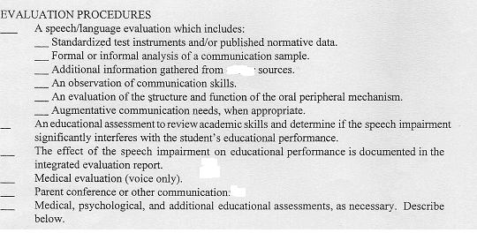

other

5. Norms have been included to aid in the classification of Articulation delayed students.

